Chapter 2 Homework：
Exercise 1: 10，11
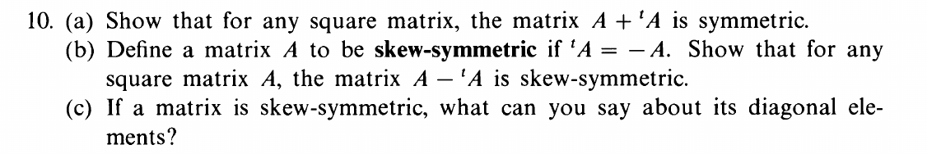
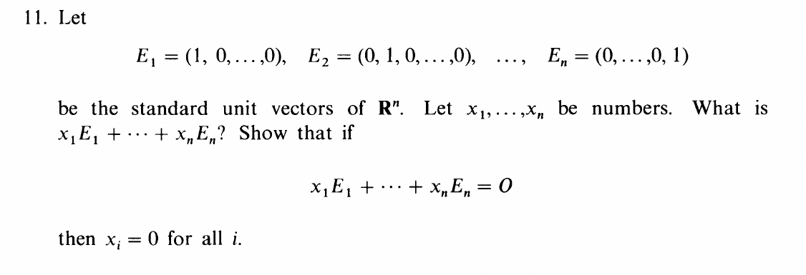
Exercise 2: 35，37
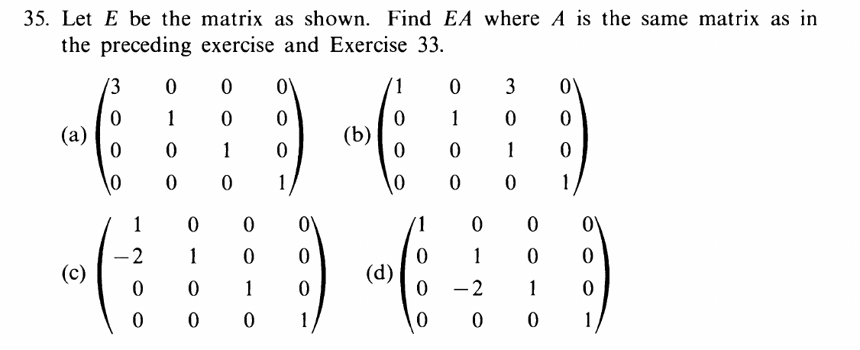
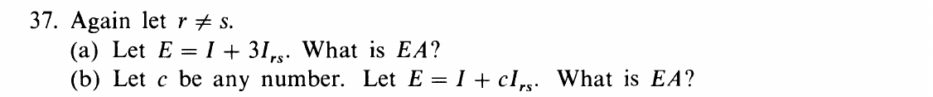
Exercise 3: 6
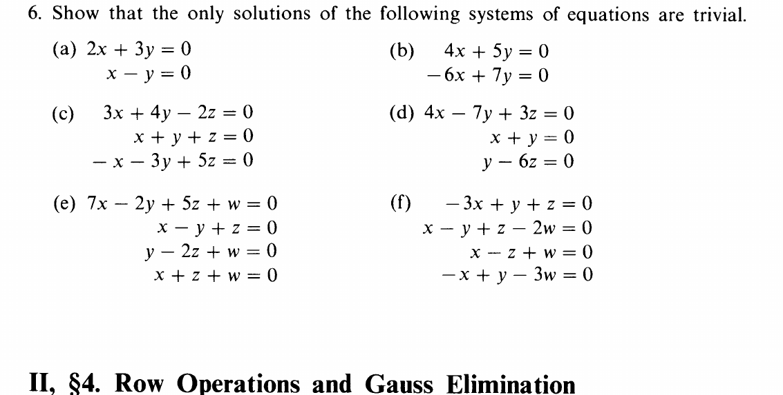
Exercise 4: 3
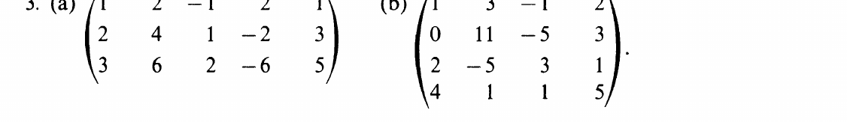
Exercise 5: 1
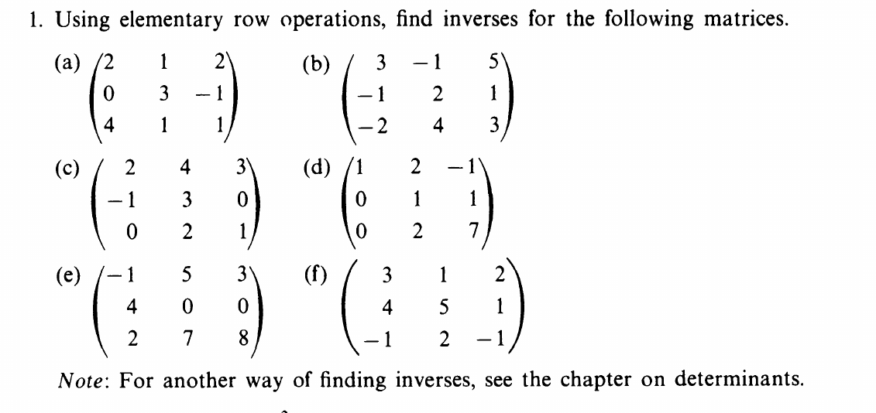
Exercise 6: 1
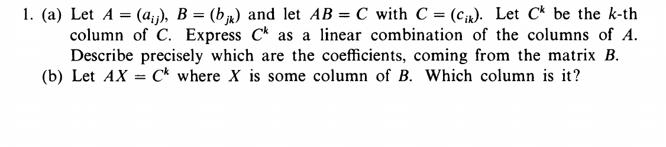

Chapter 3 Homework：
Exercise 1: 5
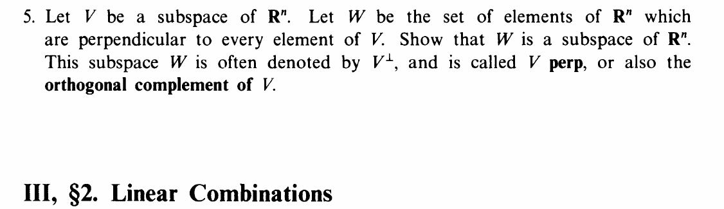
Exercise 2: 1
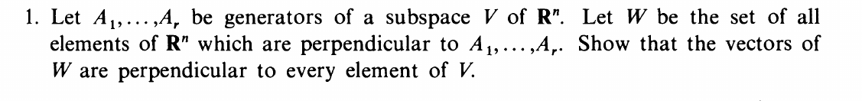
Exercise 3: 4
Exercise 4: 6
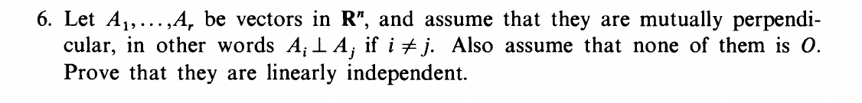
Exercise 5: 1
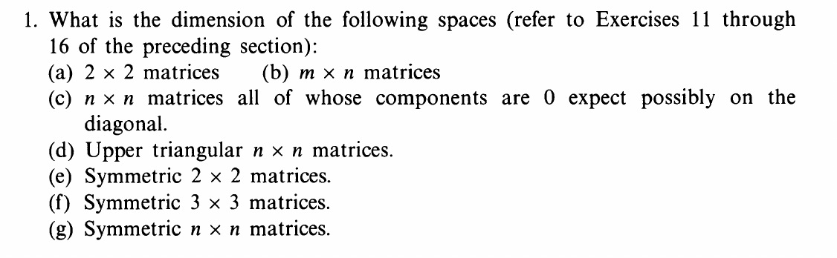
Exercise 6: 3
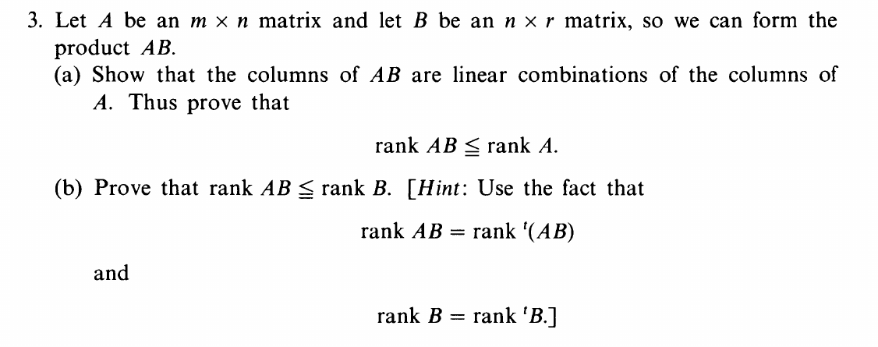

Chapter 4 Homework：
Exercise 1: 8
Exercise 2: 10
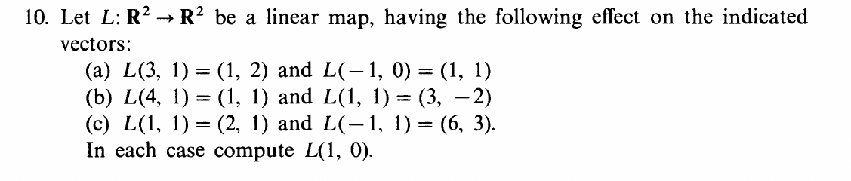
Exercise 3: 11
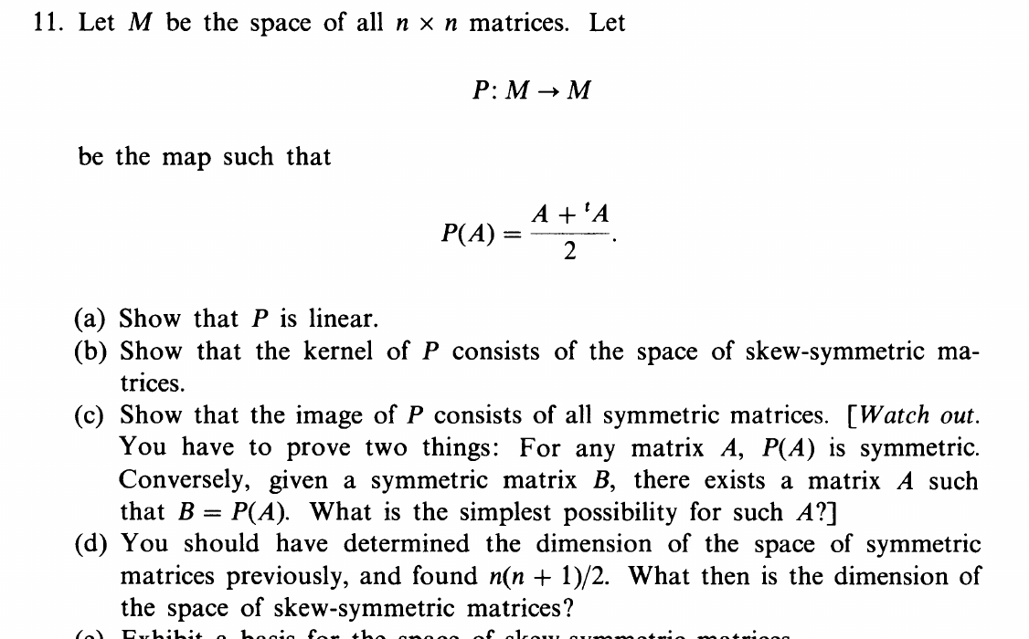
Exercise 4: 5
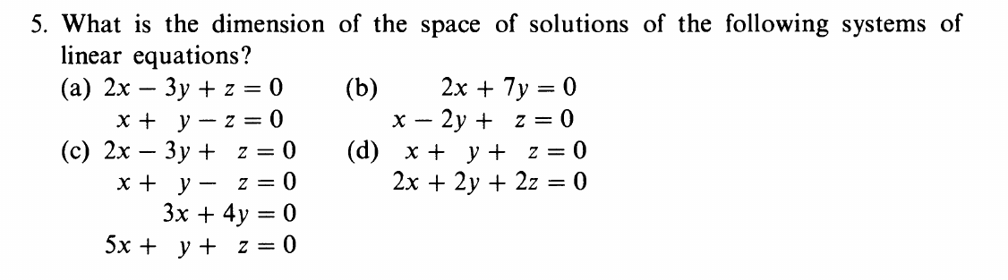
Exercise 5: 4
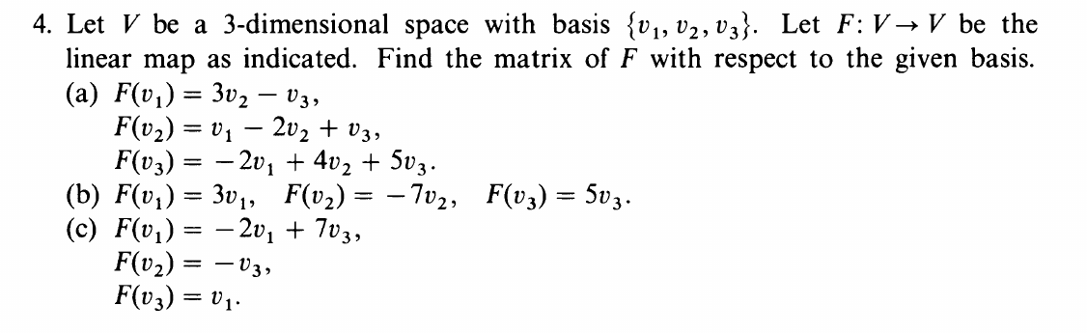

Chapter 5 Homework：
Exercise 1: 4，5
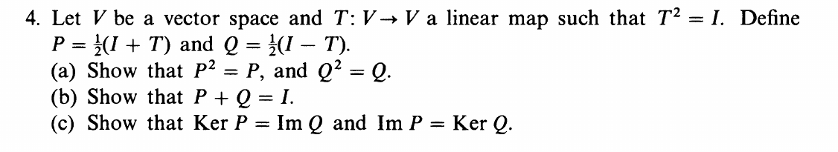
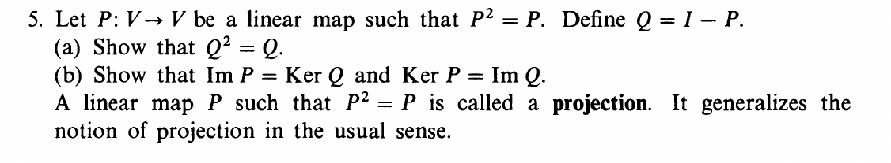
Exercise 2: 6，7
